**Module (HTML5) – 3**

1. What are the new tags added in HTML5?

HTML5 introduced several new elements and attributes to enhance the structure and functionality of web pages… new element:- ***article, section, header, footer ,nav , aside etc***

***<article>:*** Represents a self-contained piece of content that could be distributed and reused independently, such as a news article.

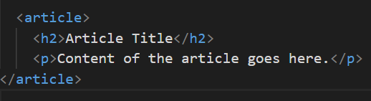

<***section***>: Defines a section in a document and is often used to group related content.

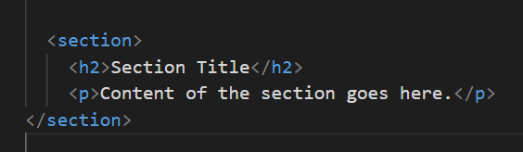

<***header***>: Represents a group of introductory or navigational aids and can contain heading.

1. How to embed audio and video in a webpage?

To embed audio and video in a webpage, HTML5 provides the <audio> and <video> elements.

The controls attribute adds playback controls (play, pause,)..

The <source> element provides multiple sources .

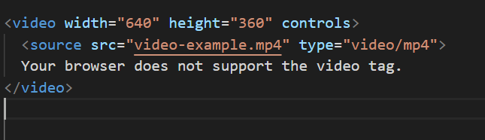

1. Semantic element in HTML5?

Semantic elements in HTML5 provide meaning to the structure of a web page, making it more readable and understandable for both developers…

* Semantic*elements-HTML-5

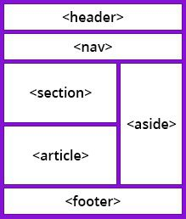

* ***header-main***

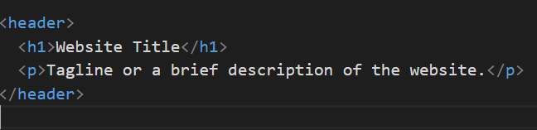

***\*Nav-bar***

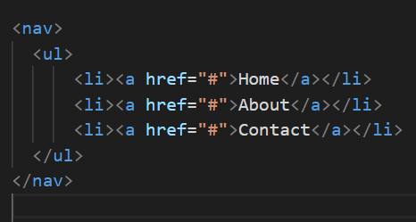 ***etc..***

1. Canvas and SVG tags.

**Canvas:**

**The <canvas> element is used for dynamic, scriptable rendering of 2D graphics. You can draw shapes, images,**



**SVG:**

**The <svg> element is a vector graphics language that allows you to define shapes, paths.**

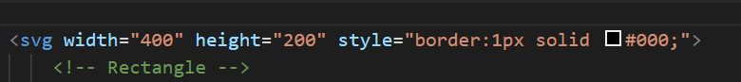

**--------------*Complete-------******assignment*----*HTML5*------------**